**Module 7 Portfolio Milestone**

Matthew Bennett

Colorado State University Global

MIS 581-1 Capstone: Business Intelligence and Data Analytics

Dr. Orenthio Goodwin

1/8/2023

Table of Contents

Abstract…..……………………………….……………………………………………………….3

Introduction……………………………….……………………………………………………….4

Objectives………….……………………………………………………………………………...5

Overview of Study...………………………………………………………………………………5

Research Questions and Hypotheses…....………………………………………………………...6

Literature Review………………………………………………………………………………....7

Research Design…………………………………………………………………………………..8

Limitations………………………………………………………………………………………..9

Ethical Considerations……………...……………………………………………………………..9

Findings………………………………....……………………………………………………….10

Conclusion……..………...………………………………………………………………...…….15

**Abstract**

Between 2003 and 2013 the population of Nigeria has increased by over 40 million people and continues to see steady growth today. As the population rises, so does the number of registered vehicles in the country. Along with new policies and initiatives that look to make vehicles more affordable for the general populous. This includes a policy to encourage and subsidize the creation of more locally manufactured vehicles with an emphasis on electric cars. All of these factors have created an opportunity for the Nigerian auto market to expand, and thus creates a vacuum of information about the market. This research project pulled a data set of online vehicle transactions in Nigeria. The purpose was to identify vehicle attributes that correlated with an increase in sales. The project utilized Tableau and SAS studio to create histograms and a regression model to identify valued vehicle attributes. The results showed that there is a large market for Toyotas, especially SUVs and sedans. Additionally, there is no correlation between drivetrain and sales. Finally, there was a positive correlation between horsepower and price of vehicle which can help inform buyers and manufacturers in the market. Overall, the aim of this project was to assist manufacturers in building local vehicles that align with consumer values. Additionally, consumers can use this information as a reference when shopping for a vehicle.

**Introduction**

“Nigeria is the largest country in Africa, both by the size of its economy and the size of its population. Between 2003 and 2013, the size of the population increased by more than 40m people…the real growth is yet to come: by 2050, Nigeria will number more than 440m people” (M2PressWire, 2014). The Nigerian car prices data set reflects the current auto market in the country. This data set was sourced from a little less than four thousand entries pulled from online sales. The number of registered vehicles in Nigeria continues to grow since 2006 which makes this data set very important for the auto market. The dataset provides a wide array of notable vehicle attributes that must be considered when purchasing a car. This is perfect because it allows for predictive modeling to find what Nigerian customers value in a newly bought vehicle. Like many people, Nigerian consumers value fuel efficiency, and this can be seen when gas prices soared in 2012. “Nigerian motorists and unions vented their anger on Monday at skyrocketing fuel prices, which more than doubled a day after government subsidies were lifted in a sweeping economic reform. Opposition leaders and unionists condemned the move by the state's fuel regulator, which they say will push up prices at a time when many Nigerians, most of whom live on less than $2 per day, already find fuel too expensive” (Reuters, 2012). It is no surprise that people in Nigeria were protesting the price hike given their average wage. Most Nigerians have no choice but to pinch pennies for the sake of their comfort and survival. This is especially important given the recent growth in registered vehicles. More and more Nigerians are buying cars for themselves and many of them have an idea of what features they prefer in a vehicle. However, vehicle prices will have to match the budgets of the average Nigerian person. It’s the auto market’s and this project’s goal to identify valued attributes and present evidence that speaks to their importance.

**Objectives**

The aim of the project is to identify valued attributes for Nigerian consumers in the auto market. Since there is a fairly new piece of the market that is constantly growing, then it is important for both the auto retailers and manufacturers to be aware of what Nigerian consumers want. As the amount of registered vehicles in the country continues to grow, so will the number of customers entering the market looking for a vehicle that matches their values. Much of this consumer base is fairly new to the market, and may not be fully aware of what they value in a vehicle. The results from this project will be able to tell the auto market and the manufacturers what Nigerians value in a vehicle and thus inform selling techniques and vehicle designs. Valuable insights pulled from this project have the potential to inform the consumers, sellers, and manufacturers within a growing industry in Nigeria.

**Overview of Study**

This project will need to support its claims with visualizations and convincing data, and there are a few tools that can accomplish said goals. This project will utilize SAS Studio and Tableau in order to support each claim and hypothesis. SAS Studio is a great tool for creating tables, predictive models, regression, and many other techniques that will be quite valuable during the research for this project. Specifically, this project will utilize histograms and regression in order to identify important vehicle attributes that can be correlated with sales volume. SAS is able to create simple and digestible models in order to find significant results much faster. This is important due to the large number of variables that will be tested against sales volume. In addition, SAS will allow this project to identify data distribution for certain factors that might benefit from visualization such as a pie chart. This project will also use Tableau for additional data visualizations. Tableau is a great tool for building easy to understand visualizations in a platform that is aesthetically pleasing. Many of the resources pulled from Tableau will serve as visual aids in the presentation section of the final project. Tables and visualizations will be constructed to make the results found in this project salient to any audience member. Specifically, Tableau will be used to present attributes that had significant positive correlations with sales volume. In other words, the platform will be used to create models and tables that can clearly express what Nigerian people are looking for when purchasing a vehicle. Overall, this will allow for tests and research to be conducted in SAS, a tool where building models and visualizations is very accessible, then Tableau will be used to express the results found in SAS. In theory, this will make for sound data and results while providing a pleasing visual experience when digesting the final presentation and overall results of the project.

**Research Questions and Hypotheses**

Research questions can provide a general direction and aim for the entirety of the project, while hypotheses take said direction and expand upon those ideas. The hypothesis provides a framework for testing the research questions proposed. There are three hypotheses proposed for each research question. The first is the null hypothesis which in this case will be used to express a situation where there is no correlation between the dependent variable and sales volume. The alternative hypothesis will express a case in which there is a negative correlation between the dependent variable and sales volume. The simple hypothesis will reflect the research question, but it will be provided in terms that can be tested. Lastly,This project will measure several variables against sales volume to identify consumer behaviors. This means that this draft will provide a few examples of the hypotheses that will be tested, but not all of them will be provided here. The final project will contain all the tested hypotheses that yielded results pertinent to this project.

**Hypothesis 1**: There is a positive correlation between a certain car make and sales volume

Ho: There are no correlations between car make and sales volume

Ha: There are no positive correlations between car make and sales volume

**Hypothesis 2**: There is a positive correlation between a certain car type and sales volume

Ho: There are no correlations between car type and sales volume

Ha: There are no positive correlations between car type and sales volume

**Hypothesis 3**: There is a positive correlation between a certain drivetrain and sales volume

Ho: There are no correlations between drivetrain and sales volume

Ha: There are no positive correlations between drivetrain and sales volume

**Hypothesis 4**: There is a positive correlation between a horsepower and vehicle price

Ho: There is no correlation between horsepower and vehicle price

Ha: There is a negative correlation between horsepower and vehicle price

All four research questions presented here all share one larger goal and that is to identify valued vehicle attributes. The first research question will test whether there is a correlation between car make and sales volume. The second will test car type against sales volume. The third will test drivetrain against sales volume. The last question will be tested with a regression model to possibly identify a correlation between horsepower and vehicle price.

**Literature Review**

In 2026, the Nigerian new cars market is forecast to have a value of $0.5 billion, an increase of 66.7% since 2021” (MarketLine, 2022). In addition, the CEIC conducted a study to find the amount of registered vehicles in Nigeria from 2005-2015. The amount of registered vehicle owners almost doubled between 2005-2006 hitting 2.8 million vehicles. As of 2015, the number of registered vehicles continued to increase to 3.7 million. According to the CEIC, a financial data firm, there is an opportunity for auto retailers as Nigeria experiences unprecedented growth in registered vehicles for more than a decade. In addition, the Nigerian government claims that they will be lowering emissions and dependence on foreign vehicles by focusing on locally-built and environmentally friendly vehicles. “By 2050, Nigeria is a country of low-carbon, climate-resilient, highgrowth circular economy that reduces its current level of emissions by 50%, moving towards having net-zero emissions across all sectors of its development in a gender-responsive manner” (Dept. of Climate Change, Federal Ministry of Environment, Nigeria, 2021). Nigeria presents opportunities for auto retailers looking to expand their customer base as the number of registered vehicles rises. Meanwhile, the manufacturing side can also pull valuable insights from this completed project.This literature review provides a narrative of a country with several economic hurdles such as rising interest rates, gas, and cereal prices. In addition, the population is expected to see an increase by a margin of over 200m between now and 2050. The number of registered vehicles is also seeing a meteoric rise as it continues to increase from 2005. The Nigerian government has also established an initiative to produce more local vehicles with an emphasis on electric cars to further suppress their footprint by 2050. Of course, Nigerian consumers may value different vehicle attributes due to their economic situation and cultural values. All in all, evidence presented here suggests a potential boom in the Nigerian auto market, and this project will aim to fill knowledge gaps regarding consumer behavior in said market.

**Research Design**

The four research questions proposed in the project will need to be tested in SAS Studio and presented through Tableau. The hypotheses will be tested by using histograms to find correlations between each of the dependent variables and sales volume. Additionally, a regression model will be utilized to find a correlation between horsepower and vehicle price. This is an effective method because the project can utilize regression to determine the value of a vehicle attribute in the eyes of the consumer. The Nigerian car prices dataset contains records which reflect online auto transactions. So, in order to test against sales volume the dependent variable will be tested against its frequency in the data set. This will show us the frequency in which certain makes, car types, and drive trains are purchased. The first three research questions will be tested using histograms because the frequency in this data set is equal to sales volume. The fourth and final research question will be tested using a regression model with horsepower as the continuous variable and vehicle price as the dependent. For the regression model, an alpha under 0.05 model can predict the continuous variable at a 95% confidence level. With an alpha over 0.05 the null hypothesis will be accepted.

**Limitations**

There are a few limitations that arise when building the roadmap for this research project. The first and major issue is the sheer amount of variables that may need to be tested to get the desired results. It’s been mentioned previously that this study will aim to address four research questions, and those questions will certainly be answered. However, this project also aims to get a better understanding of the Nigerian auto consumer, and what they tend to value. The final project may fail in terms of comprehensiveness and may slightly stray from the initial vision. The initial vision of this project was to test most of the vehicle attributes through regression, but after testing it was found that some of the variables were not data type for a regression model. Another limitation may be the use of Tableau, and it has been stated earlier that Tableau would be used to cleanly present data for the final presentation and paper. Although, the author of this paper has rarely ever used Tableau, so that tool may be switched out with R or SAS Studio to ensure the completion of the project. In addition, if Tableau is not used for clean visualizations, then SAS Studio will serve as a fine substitute, and R will be used as a second resource.

**Ethical Considerations**

There are a few ethical considerations that should be addressed if this project succeeds and realizes any of the hypotheses proposed. It’s important to not provide auto sellers too much bargaining power. The idea here is not to provide auto sellers with the information to manipulate their customers, but it is to inform the auto sellers of what the typical consumer values in a vehicle. The vision of this project was to empower auto consumers by informing their buying needs. Also, to indirectly empower them by informing manufacturers, so they can produce vehicles that are catered to the culture and the market. Buyers and sellers should be able to use this resource to inform selling points and decision making during prospecting and auto transactions. If this project can provide a positive impact for both auto manufacturers and customers, then one can expect that the ethical goals have been met.

**Findings**

The proposal of this final project intended to use SAS Studio for testing hypotheses and Tableau would be used to present the data. Additionally, it was proposed that three research questions would be answered, and the Nigerian auto market would be further supported with additional findings. The first hypothesis was built to find a possible correlation between car make and sales volume in order to determine popular car makes in Nigeria. In Figure 1 one will notice that Toyota vehicles are sold much more often than other vehicles. This makes sense because Toyota is known for making dependable and affordable import vehicles. A perfect car for a growing auto market where everyone is on a budget. Also, notice that the other leading manufacturers are either affordable or luxury import vehicles. Nigeria seems to have a large market for affordable long lasting vehicles with a smaller market for luxury imports as well. This data confirms the first hypothesis, and Toyota is a dominant brand in Nigeria, and has a significant positive correlation with sales volume. Manufacturers can examine vehicles from Toyota and Honda to inform their design process. They will most likely find that it’s the affordable qualities of these vehicles that make them so appealing to the public. In addition, their relatively safe and are often great family vehicles.

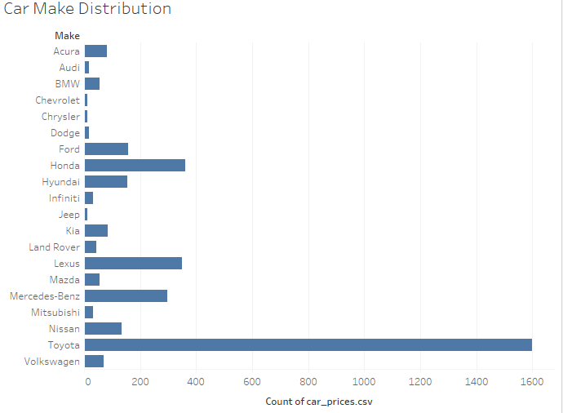

*Figure 1: Car Make Distribution Pulled from Tableau*

The second hypothesis was to find a correlation between a certain car type and sales volume. The aim here is to further identify what the Nigerian auto market tends to value. In Figure 2 the car type histogram provides a good look at what consumers are looking for. It seems that SUVs are very popular with Sedans at a distant second. There is a pretty small market for convertibles and coupes which suggests that most luxury car purchases are not often sports cars. Notice that all other car types are insignificant in volume compared to SUVs. This probably due to the extra seats available in SUVs for a country that is mostly collectivist. The data supports the second hypothesis because there is a significant and positive correlation between SUVs and sales volume.

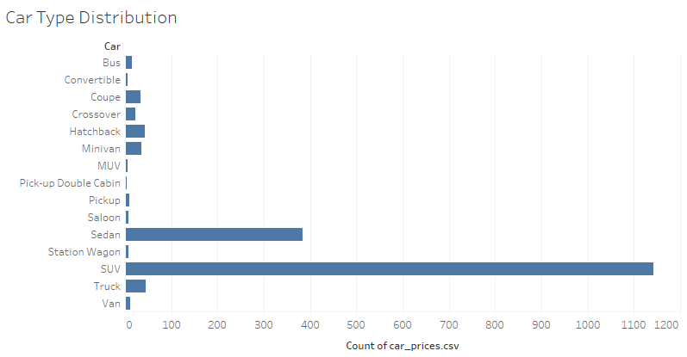

*Figure 2: Car Type Distribution Pulled from Tableau*

The third research question presented in this project looked to find a specific drivetrain that correlated with sales volume. Again, with the purpose to continually build out a profile for what Nigerian consumers want in a vehicle. Figure 3 displays the sales distribution of certain drivetrains. Notice that All Wheel, Front, and Front Wheel are all sitting at similar values which suggests that Nigerian consumers don’t want or need Rear Wheel drive in any circumstance. This does mean that the null hypothesis will be accepted because there is no correlation between a certain drivetrain and sales volume. With the acceptance of the null hypothesis one can determine that drivetrain is not a valuable attribute to test against sales volume. However, it does provide this project with a smaller intersection of vehicles that Nigerian consumers value. In future iterations it would be beneficial to include any drivetrain related information in the background as opposed to using the attribute for statistical testing.

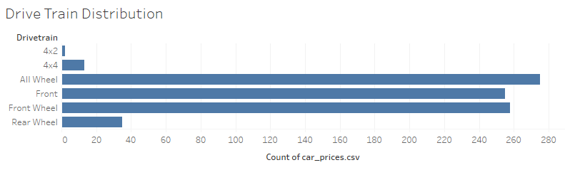

*Figure 3: Drivetrain Distribution Pulled from Tableau*

There was one more test to help support this project, and that was to identify vehicle attributes as price indicators. This project proposed a fourth research question to test horsepower against vehicle price. The purpose here being that the Nigerian auto market will be informed on what attributes contribute significantly to the vehicle’s price. Figure 4 shows a regression model of horse power against vehicle price. Notice that there is a positive correlation between the amount of horsepower and vehicle price. This can be seen by observing the trend lines on Figure 4, and observing some of the predicted values generated from the model. This can inform consumers that they want an affordable vehicle with a lower horsepower. In addition, Nigerian manufacturers can use this information to build vehicles that will be tailored to the local market. Overall, the simple hypothesis was confirmed, so that there is a positive correlation between horsepower and vehicle price.

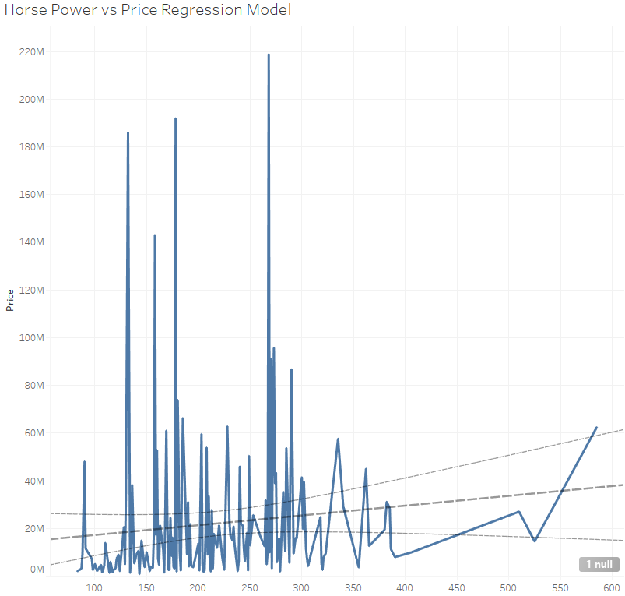

*Figure 4: Horsepower vs. Price Regression Model*

After testing, this project was able to build a reliable profile for what many Nigerian consumers value in a vehicle. First, Toyotas are very popular within the Nigerian auto market with Hondas at a close second. This project also found a small, but stable market of luxury import vehicles, and this is most likely to serve the wealthier residents in the country. Secondly, testing revealed that SUVs are extremely popular within Nigeria with sedans at a distant second. This probably means that Nigerian consumers value the number of seats in a vehicle and safety features. Third, testing revealed that there is no correlation between a certain drivetrain and sales volume. This was apparent because sales were pretty evenly distributed between the different modes. Since drivetrain is not highly valued for consumers, then it must mean that they value the safety and number of seats in an SUV rather than its four wheel drive capabilities. Lastly, horsepower was tested against vehicle price which revealed a positive correlation between the two. So, Nigerian consumers should be looking for Toyota SUVs or sedans with a lower horsepower. Many consumers will have to make the choice between an SUV or sedan depending on their needs and budget. Manufacturers should also use this information to build local vehicles that fit this general profile.

**Conclusion**

Overall, this project found that the Nigerian auto market values affordable, durable, and spacious vehicles. According to this study, most registered vehicle owners should be buying a Toyota SUV at a lower horsepower. The results presented in this project should be able to inform auto manufacturers, retailers, and buyers of consumer values in the market. Additionally, interested parties will be able to read this study and identify a car culture specific to Nigeria. Retailers and manufacturers can use the findings presented here to inform selling and design processes in order to boost sales. Manufacturers are subsidized and now have the information to design and release vehicles tailored to the Nigerian auto market.

References

Busse, M. R., Lacetera, N., Pope, D. G., Silva-Risso, J., & Sydnor, J. R. (2013). Estimating the Effect of Salience in Wholesale and Retail Car Markets. The American Economic Review, 103(3), 575–579.

Campbell, Lord. (1968). Journal of Retailing, 44(1), 54.

CEIC. (2015). Nigeria Registered Motor Vehicles. Nigeria Registered Motor Vehicles, 2005 – 2022 | CEIC Data. Retrieved November 16, 2022, from https://www.ceicdata.com/en/indicator/nigeria/motor-vehicle-registered

Department of Climate Change, Federal Ministry of Environment, Nigeria. (2021). United Nations Framework Convention on Climate Change. 2050 Long-Term Vision for Nigeria (LTV-2050). Retrieved November 27, 2022, from https://unfccc.int/sites/default/files/resource/Nigeria_LTS1.pdf

Emerging Consumer Lifestyles in Nigeria. (2014). M2PressWIRE.

Malhotra, K., & Kavita. (2022). Consumer Buying Behavior and Brand Choice in Sport Utility Vehicle (SUV) Segment: A Literature Review. IUP Journal of Brand Management, 19(1), 40–52.

MarketLine Industry Profile: New Cars in Nigeria. (2022). New Cars Industry Profile: Nigeria, 1–44.

O'Leary, Z. (2021). The Essential Guide to doing your research project. SAGE.

Olurounbi, R. (2022). Nigeria Inflation Exceeds Expectations on Cereals, Gas Prices. Bloomberg.Com, 1.

Reuters News Agency. (n.d.). Nigerians fume at fuel price hike. Toronto Star (Canada).